PADDLIN’ SPIRIT

Today I will be sharing how life can shift and boundaries can change, how I’ve created a foundation for myself so that I no longer feel enslaved but am free from a past that once held me — how as I continue to let go, I grow spiritually and become stronger. I will show how the work in this exhibition titled Their Spirits relates to those themes of change and transformation.
First I’d like to tell you about two trees that were cut recently on my farm and how they relate to my father.
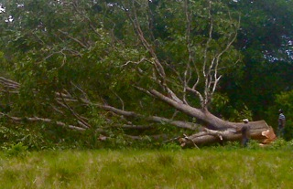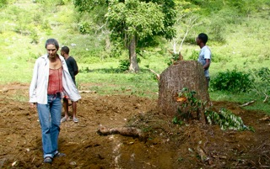
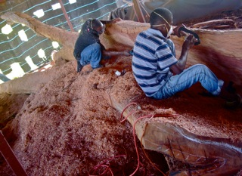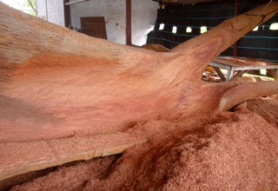
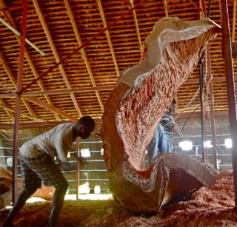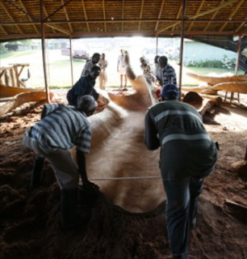
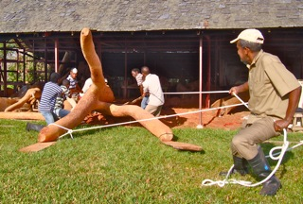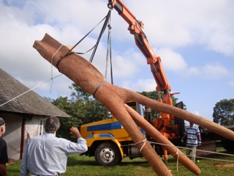
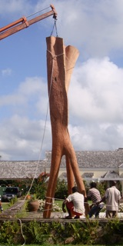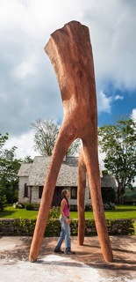
I deeply regret cutting this Cedar tree. She stood beautiful, proud and perfect. I’d promised never to cut…yet, there came a day when I was searching for a special form and she called to me. The chain saw man remarked that she was rotting and pointed to a dark area on her trunk. I believed him and gave permission but when she fell, I hurt. I still hurt. She was perfect. I miss her. The field is vacant and ordinary now.
A week ago I learnt that the Guango tree had been cut.
I was full of rage, anger and disappointment.
I went to look where the tree had been and found the site raw, gaping and unceremonious — the tree crumpled, silent. It made me think of my father on April 2nd, 2013, lying lifeless, mouth gaping, on the hospital bed in that grey empty room. Where was that strong, full of life man — that bustling, rustling that is life? This is so silent and feels not part of his plan.
The last time I saw the tree it spread across the space, shimmering, filling the field with majesty.

I’m going to talk about the day my father was cremated.

My mother and I are at the Sunset Crematorium. We’re glad we came. They placed his body in the furnace and we‘re able to peep through a twelve-inch opening to see the back of his head, a little forehead, the top of his nose and his cheeks. His shoulders are bare with a thin white cloth covering the rest of his body that cascades away into the dark like Dali's Christ on the cross. We saw the flames and then closed the tiny door. My mother was moved to tears, the first I’d seen since his passing.

We've been sitting under a Naseberry tree on a plank buoyed by paint pans, buffeted by a strong breeze on the top of a hill where the blue sea fills the horizon, making the sea seem higher than the land. The view is soothing, peaceful. We watch the heat shimmering out of the chimney and know that he is free. Hardly anyone is here.

My mother and I watched the bones removed, crushed and placed in the urn — I needed to know they were his…

I let go of my trees and I let go of my father, however, had those two experiences happened to me fifteen years ago, I would not have been able to stand before you today. It has taken me a long time to come to a place inside myself where I can say, alright tree, I give you to God, and, ok God, I release my father to you, while knowing they live in my heart but are no longer here where I can touch and feel them.

The following works that I’m about to show are my creations and they span twenty-five years. I now realise these pieces are self-portraits — my subconscious talking to me. They show the transformation from my abandoned inner child, to me as victim, then to me becoming the warrior, and finally, me as the victorious ‘spirit dancer’. These portraits help to locate the anchor that sunk me ending with the joy that currently surrounds me.

At six years old I was inappropriately touched. At nineteen, I was raped. At thirty-three, I was raped again. At forty, weighing ninety pounds, I felt overwhelmed by life.
Journal entry, “Today I feel angry! I’ve had enough of life. My bones stick out everywhere — clothes-pin- pegs that clunk against the wall as I try to swing my legs.”
“Laura, I see you returning yourself to a little girl so as to avoid having those painful experiences.” This was a quote by a woman in group therapy. Her words were startling, shaking me awake.
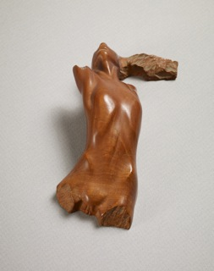 BROKEN OPEN, 1986
The sculpture BROKEN OPEN is just as the title suggests — I felt invaded, torn, unclean. I was, broken open.

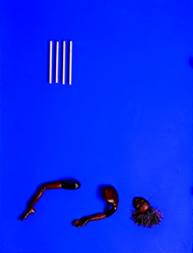 MOONSHINE BABY, 1986
The assemblage MOONSHINE BABY shows my abandoned inner child who is isolated and no longer able to dance in the moonshine or play children’s games.
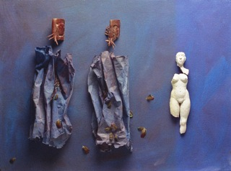 PAPER GODS, 1986
PAPER GODS — when creating this piece I told myself I needed a purple background with two animal forms on the left and a broken Greek body on the right. When I looked at the finished product I was shocked and immediately knew the animal forms were my offenders and the broken body was me! I went in search of a title that would be misleading.
But, not wanting to hide any more, I now share these experiences to show how they pushed me to look for new solutions and opened me to a more profound and meaningful life. My broken body mends and is rebuilt to make space inside me for something new. I could be stuck in the victimization of my past — they did this to me, I am in pain, I hurt — but I choose to recognise the good that came from the situation. I would not be doing this artwork, nor would I be able to emotionally move those who have shared a similar circumstance.

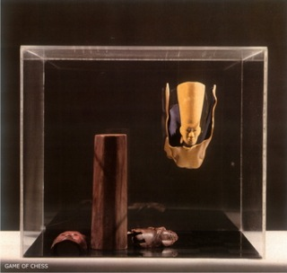 GAME OF CHESS, 1987
GAME OF CHESS — another obscure title but it is about my need to transcend those darker times.
So, I remember waking up one morning and realising I didn’t like myself. I was supposed to be a wife, a mother and a community leader. Amid my confusion and crowded by crushing feelings of sadness and despair, I fortunately turned within and began a most wonderful healing journey. I learnt meditation and prayer, I read metaphysics, made friends, danced, played, did counselling, exorcised demons, and made peace within myself — in other words, I brought balance and more love into my life.
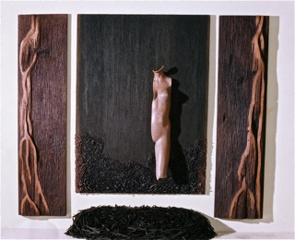 GODDESS OF CHANGE, 1996
Goddess of Change shows what I was feeling inside and reflects my new openness to life. Whereas my earlier work was small and often assembled in boxes, GODDESS OF CHANGE — box-less and measuring 8 feet by 10 feet — filled me with hope and felt wonderfully new. I was no longer confined.
Then I created SINGING OVER BONES, inspired by Clarissa Pincola Estes’ story, La Loba, The Wolf Woman. La Loba lives in hidden places, collecting the bones of endangered animals. When she has an entire skeleton laid out before her, she sings. La Loba sings so deeply the creature comes to life and sprints away. Somewhere in its running it becomes a laughing woman.

Nearing the end of the construction of this installation I finally understood that I was ‘singing over my own bones’. This ‘singing’ that I speak of represents all of my praying, dancing, reading — whatever it took to breathe life into me — hence the reason for my attraction to the story.
In this work you can see my body becoming whole.
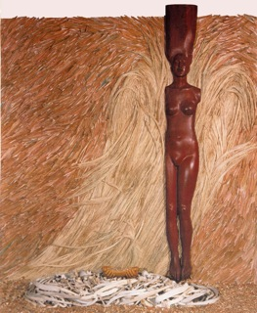 SINGING OVER BONES, 1997
With inner transformation taking place and with my life and work blossoming, I created SPIRIT DANCER. I used feathers to describe the lightness and freedom I now felt. Straw symbolised playfulness, and the clay, my connection to the earth and my re-established intuition.
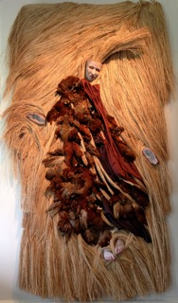 SPIRIT DANCER, 1997

Phibbah is my next self-portrait, seen on the wall over there. She represents my long ago feelings of being emptied, limp, debased. 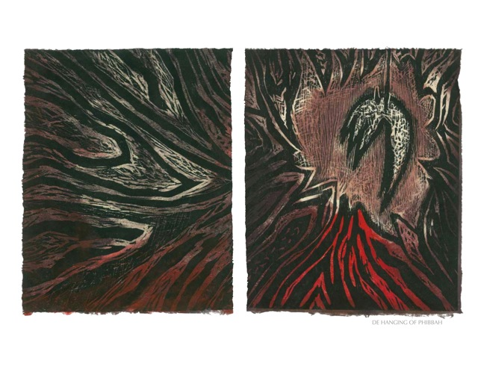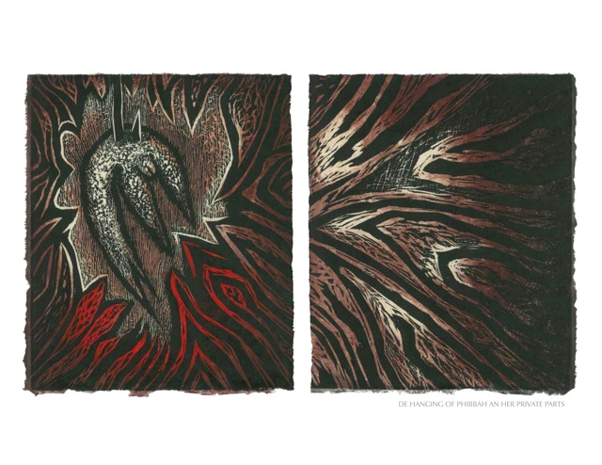
DE HANGING OF PHIBBAH AN HER PRIVATE PARTS, 2010
I found Phibbah in fellow artist Jocelyn Gardner’s print series. Phibbah was a slave. She was the mistress of Thomas Thistlewood who rented her for £18 per year in approximately 1760.
When I was invited to create my Phibbah prints in 2011, I was nervous at revisiting my past. However, I felt compelled to accept this project and knew that I could truly relate to Phibbah and use my voice to speak for her and other ‘damaged’ women of the world. I created WEEPING IN THE BLOOD for all of us women who have been harmed so deeply.
I further created a second version of Phibbah in wood.
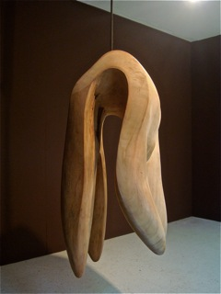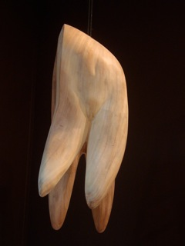
DE HANGING OF PHIBBAH AN HER PRIVATE PARTS, 2012

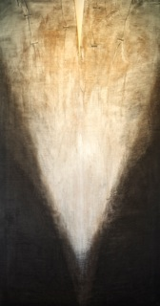 NIGHT MIST, 2011
NIGHT MIST — this is my last self-portrait that, at this moment, feels like who I am today — I feel light yet more grounded, euphoric at times and more accepting of what life has to offer and what I need to learn.
I would like to now take you into my world and home and give you a short description of the view from my bedroom window.
A red sphere eases its way into the morning. Roosters call to each other and a bull sighs warm moist air adding to mist that is rising and falling, veiling and unveiling the hills. Or is it that the hills are riding a carousel, reminding me of floating in a hot air balloon, leaving me saturated with the joy of being alive.
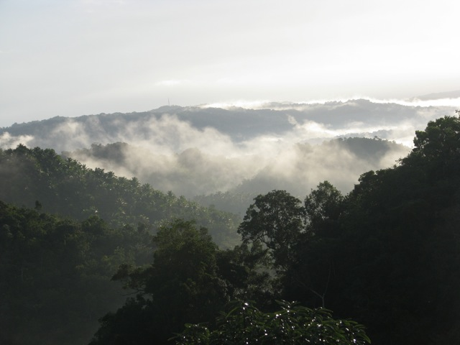

I live on a farm in Jamaica that has Taïno (the first people who lived in Jamaica) middens (their refuse heaps). There are also stonewalls built by the enslaved African people who worked, on our farm. There are burial grounds for those African people, on our farm. Some of their descendants still work, on our farm. At any moment I can choose to look at a list on my computer — an 1820 inventory, listing the names of 62 men and 63 women who were someone’s property, who were enslaved, and, who worked, on our farm! I am filled with grief at these realisations. I feel responsible that, while it is my turn to live on this farm, I need to do what I can to heal the land and those who live here.

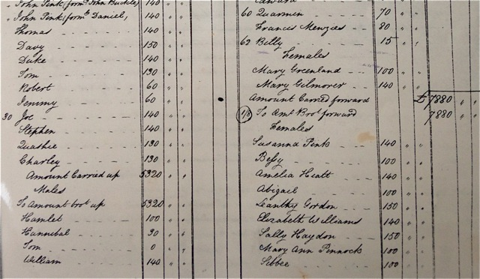

In 1996, José Manuel Noceda, a Cuban curator, visited my studio and remarked, “I see you working with the memory of ancient materials and reusing them to create ceremony for the healing of the earth.” At the time, José’s words were surprising because, though I was aware that this was my concealed intention,
José recognized it, named it, and brought it into the light. This was immensely encouraging for me.

My strong feelings about our people of Jamaica, combined with my experience of moving from darkness to light, are the foundation for works like REDEMPTION SONG and THEIR SPIRITS GONE BEFORE THEM.

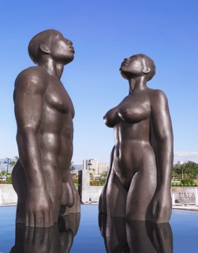 REDEMPTION SONG, 2003

At the time while creating REDEMPTION SONG, this work felt completely right to me. With the unveiling of the monument however, there was an explosion of public anxiety, wrath and discussion. In the beginning I was terrified by these reactions. What had I done?

In support, Dr David Boxer, the then Director of The National Gallery of Jamaica, wrote in a letter-to-the-editor published in the Jamaica Gleaner, "…I see two human beings, two black human beings, one male, one female, standing in ‘the healing stream’. They are resplendent in their purity, their heads are raised heavenwards in prayer…yes, this is a prayer — the work is a silent hymn of communion with, and thanksgiving to, the Almighty." I read this comment and felt, he ‘sees’ me, he understands exactly my intention. I was deeply relieved, feeling that if he could understand, in time, so would others.

The REDEMPTION SONG miniature figures — with their dignity and upward gazing — occupy the canoe before you today. These figures were inspired by the words, None But Ourselves Can Free Our Mind, words that were first said by Marcus Garvey and then sung to fame by Bob Marley. None But Ourselves Can Free Our Mind. I now know that I must be the one to pull myself out of my own darkness, so that I may be able to come back to the light.

In October 2006, when THEIR SPIRITS GONE BEFORE THEM was first exhibited — I again held my breath. I had taken my ‘healed’ Redemption Song figures and placed them in a slave canoe! What would people say? It had felt completely natural for me to place them there.

In this exhibition in Kingston, at the Institute of Jamaica, THEIR SPIRITS GONE BEFORE THEM was surrounded by symbolic doorways — doors as openings for our new beginnings, surrounding the canoe with its precious cargo — doorways for them and for us to leap through if we so choose.

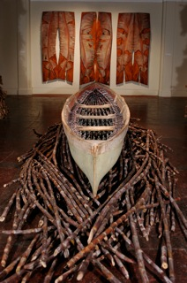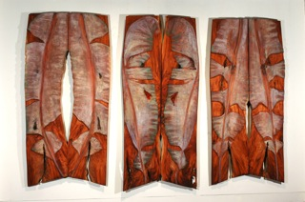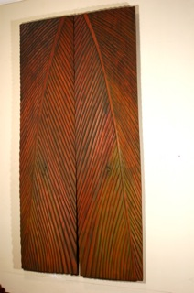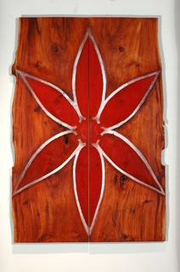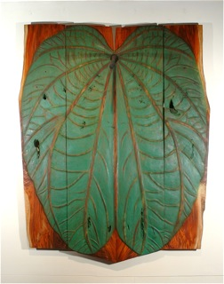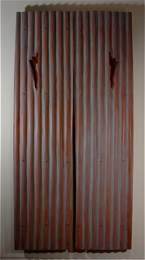

In 2006, I found a paddle at the waters edge of Paradise Cove (appropriately named) on the south coast of Jamaica. I took this rustic, weather-beaten oar home with me. It lived with me, captured my heart and eventually inspired the PROPEL series.

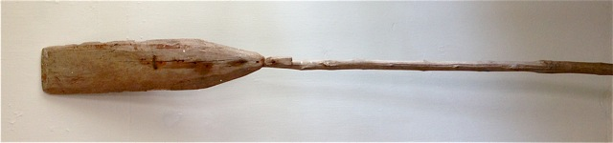

In 2009 I was moved to search for tools that excited me and rediscovered my paddle. It stirred feelings of joy, of being free on the water, whether pushing or pulling, but moving, going somewhere, somewhere wonderful. I needed shapes that communicated this magic that I felt.

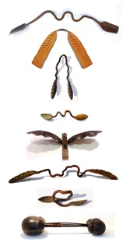 PROPEL SERIES, 2010

As well, I love that the Egyptians created boats with oars to row the spirits of their dead across to the other world. However, as we are not dead and do not yet need to 'cross over', the meaning of OAR FOR BA, seen here in this exhibition, is a metaphor for awakening — the art of paddling spirit into our lives. If this sounds as though spirit is not here and now, it is! But for myself, it’s been a long journey, an unfolding, a ripening to where I now believe spirit never dies and we are one living, breathing organism.

Part way through the PROPEL series, Haiti experienced that horrendous earthquake and I found myself paddling their spirits across in prayer.

All my work is connected just as the air connects us. Inspiration for my artwork comes from everywhere —a word, a patina, an experience…
It’s important to me that my art speaks to you. At the time of the opening of Their Spirits, it was heartening to be told by a viewer that upon reading the poem, ‘I am a thought …’ he felt peaceful. I’m most grateful to The International Slavery Museum, here in Liverpool, for allowing me to join with them to effect such transformation.
The International Slavery Museum is indeed bold and to be commended. Instead of sweeping under the carpet sensitive and controversial subjects like slavery and the violence in the Belgian Congo, they’ve confronted the issues head on, giving each side an opportunity to say its piece (‘peace’). For me this is the real work that our planet needs at this time — a new consciousness to regain our dignity and humanity.
In conclusion, I released my father and the trees to spirit. The Cedar tree has become a sculpture. I was broken but am transformed. The paddles are implements about my movement forward. Redemption Song is about our souls being free. The canoe is significant as a sign of movement, of change, and of how we can let go in life. The body may be enslaved but our souls are free.

